1559. Detect Cycles in 2D Grid

Question :[ https://leetcode.com/problems/detect-cycles-in-2d-grid/submissions/1988550528/?envType=daily-question&envId=2026-04-26 ]

Solution :
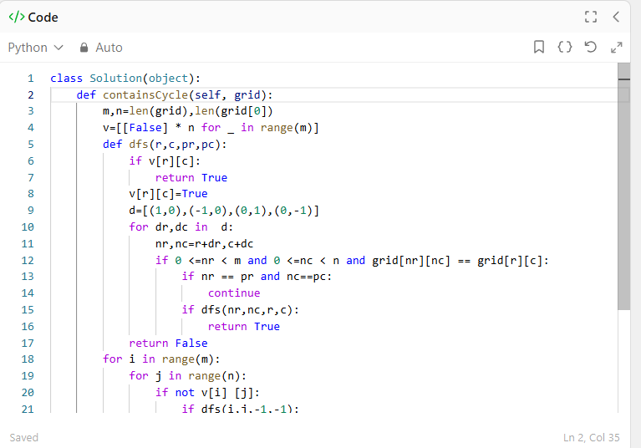
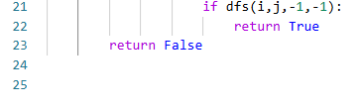







Complexity

Time: O(m × n)

Because visited each cell once

Space: O(m × n)

